**Software Testing Assignment**

**Module–1(Fundamental)**

* What is SDLC

1. SDLC means Software development life cycle which is a structure imposed on the development of software product. It defines the procees for planning, ananlysis, design, implementing, testing, maintenance and support. There are many different models in SDLC, which runs the process by step by steps or different phases. The methodology of SDLC process can be different in all the companies and industries. SDLC phases include Requirement Gathering, Analysis, Design, Implementation, Testing, Maintenance.

* What is software testing?

1. Software testing is a process of identifying the correctness, completeness, and quality of a developed software. It is a process of evaluating the system or its components to find whether it satisfy the desire requirement or not. Software testing is executing a system to find any gaps, errors or missing requirement in contrary to the expected requirements.

* What is agile methodology?

1. Agile model is a SDLC model which is a combination of iterative and incremental process model. It focus on the the adaptability and customer satisfaction by delivering the working software product. It works by breaking the procees into small builds and this builds are provided in iterations. Each iteration lasts for about 1 to 3 weeks. Every iteration involve cross functional teams working simultaneously on various areas like planning, requirements, analysis, design, coding, unit testing and acceptance testing.

* What is SRS

1. SRS is software requirement specification, it is a complete description of the behaviour of the system to be developed. It includes the set of use cases that describe all interaction that the user will have with the software.

* What is oops

1. Object oriented programming system: black box testing, functional testing.

Identify the objects and assign the responsibilities to the object. Object can communicate with other object by sending message. Object is like a black box, the internal data is hidden.

* Write Basic Concepts of oops

Object

Class

Inheritance

Abstraction

Polymorphism

Encpsulation

* What is object

1. Instances of a class. To create a memory of a class. To access the whole property of a class except private.

* What is class

1. A collection of a data member and member function with its behaviour. Class can be considered as the blueprint of object.

* What is encapsulation

1. Wrapping up of data into a single unit, private the data member or member function. Encapsulation is placing the data and relevant functions that work.

* What is inheritance

1. Properties of a parent class extend into child class. Inheritance describes the relationship between two class. Main purpose is reusability, extendibility.

There are mainly 5 types: Single, Multilevel, Heirarchical, multiple(Java does not support), Hybrid(Java does not support).

* What is polymorphism

A) Ability to take one name having different forms, many forms or multiple forms. It allows different objects to respond to the same message in different ways.

There are two types: Compile time(Method overloading) Runtime(Method overrading)

* Draw Usecase on Online book shopping

A)

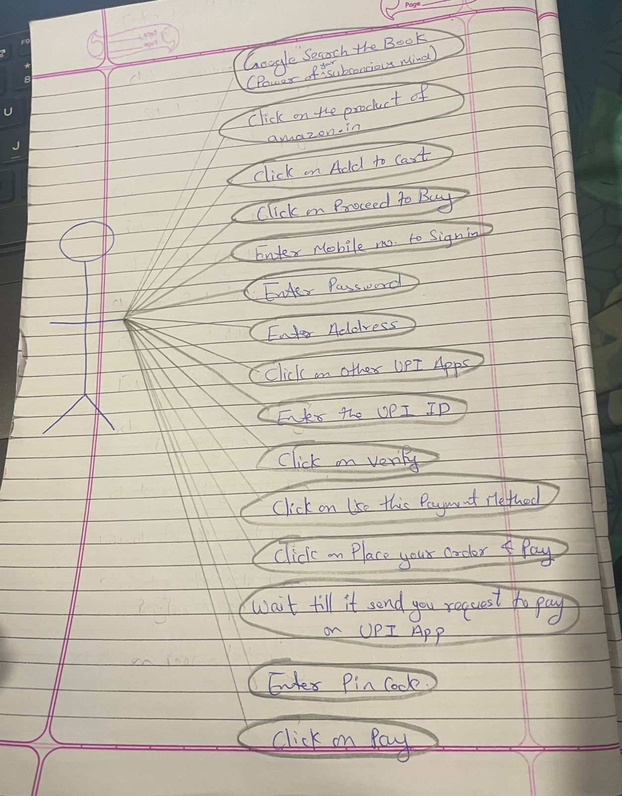

* Draw Usecase on online bill payment system (paytm)



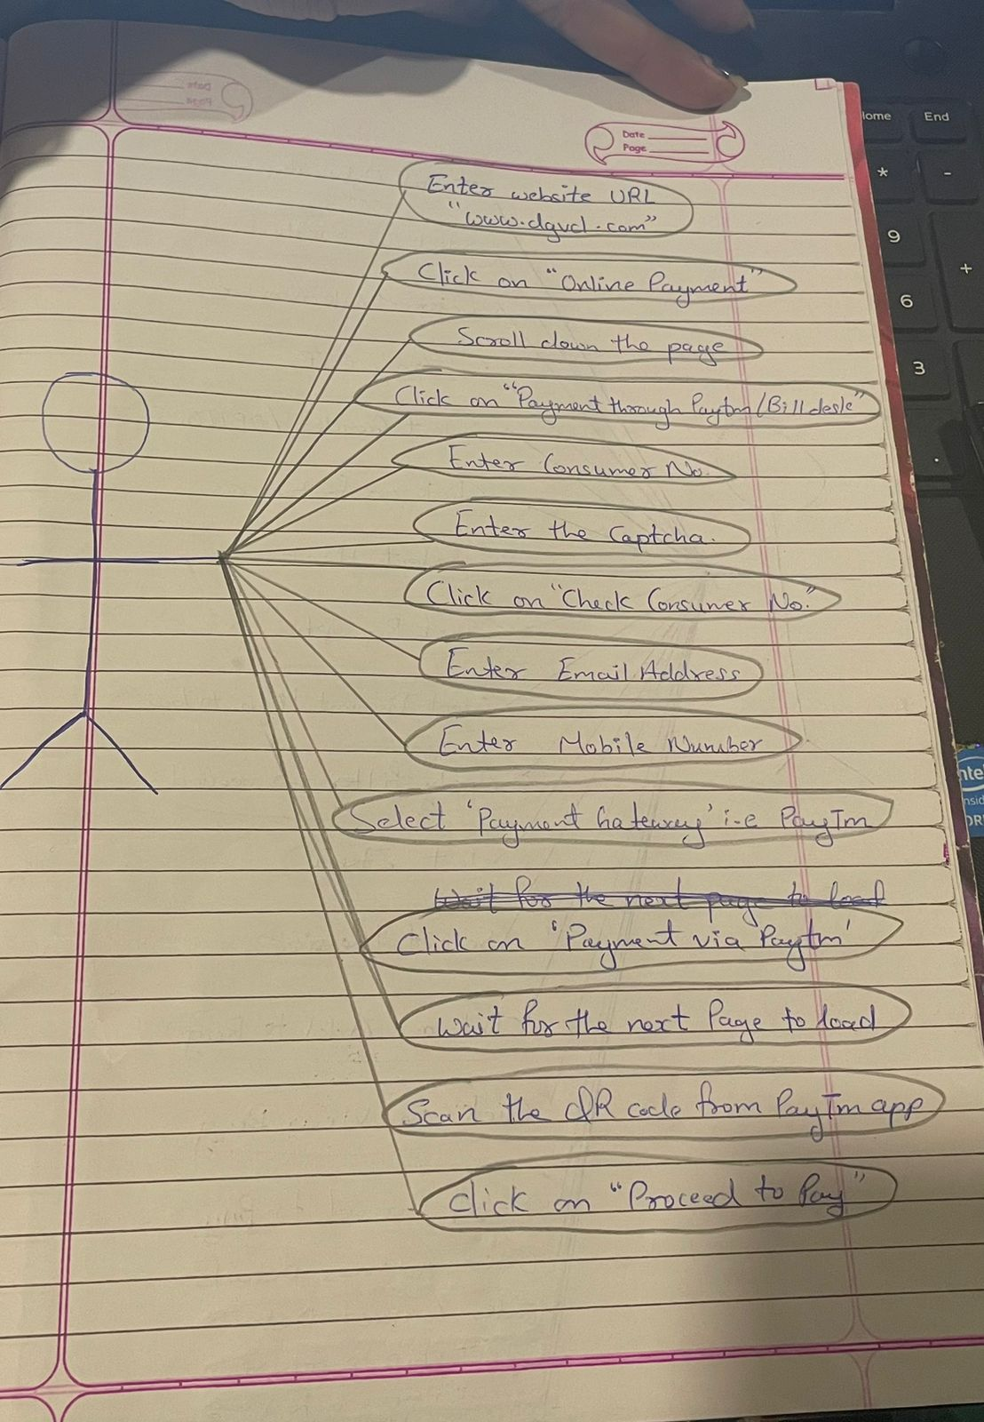

* Write SDLC phases with basic introduction

1. **Requirement** gathering: Customer needs/Requirement

**Analysis**: Represent the “What” phase, what is to be built. This phase defines the requirement of the system.

**Design**: It designs the architecture document of the process. Test plan

**Implementation**: The team build exactly what has been requested and construct the solution in software.

**Testing**: Testing the quality of the software & validate the solution.

**Maintenance**: Changing the process after deployed. Repair defects.

* Explain Phases of the waterfall model

1. Requirement

Analysis

Design

Implementation

Testing

Maintenance

* Write phases of spiral model

1. Planning

Risk Analysis

Engineering

Customer Evaluation

* Write agile manifesto principles

1. Individaul Interaction

Working Software

Customer collaboration

Responding to change

* Explain working methodology of agile model and also write pros and cons.

1. Agile model believes that every project needs to be handled differently and tailored to best suit the project requirements. In agile the tasks are divided into small time frames to deliver specific feature for a release.

**PROS:** Promotes teamwork and cross training

Very realistic approach to software development

Resource requirements are minimum

Easy to mange

Give flexibility to developers

Minimal rules and documentation easily employed

**CONS:** Agile leader or agile PM practice is must.

Heavily depends on customer interaction, if customer is not clear than the team can be driven to the wrong direction.

More risk of sustainability, maintainability & extensibility.

Deliver management is strict.

* Draw usecase on Online shopping product using COD.

A)

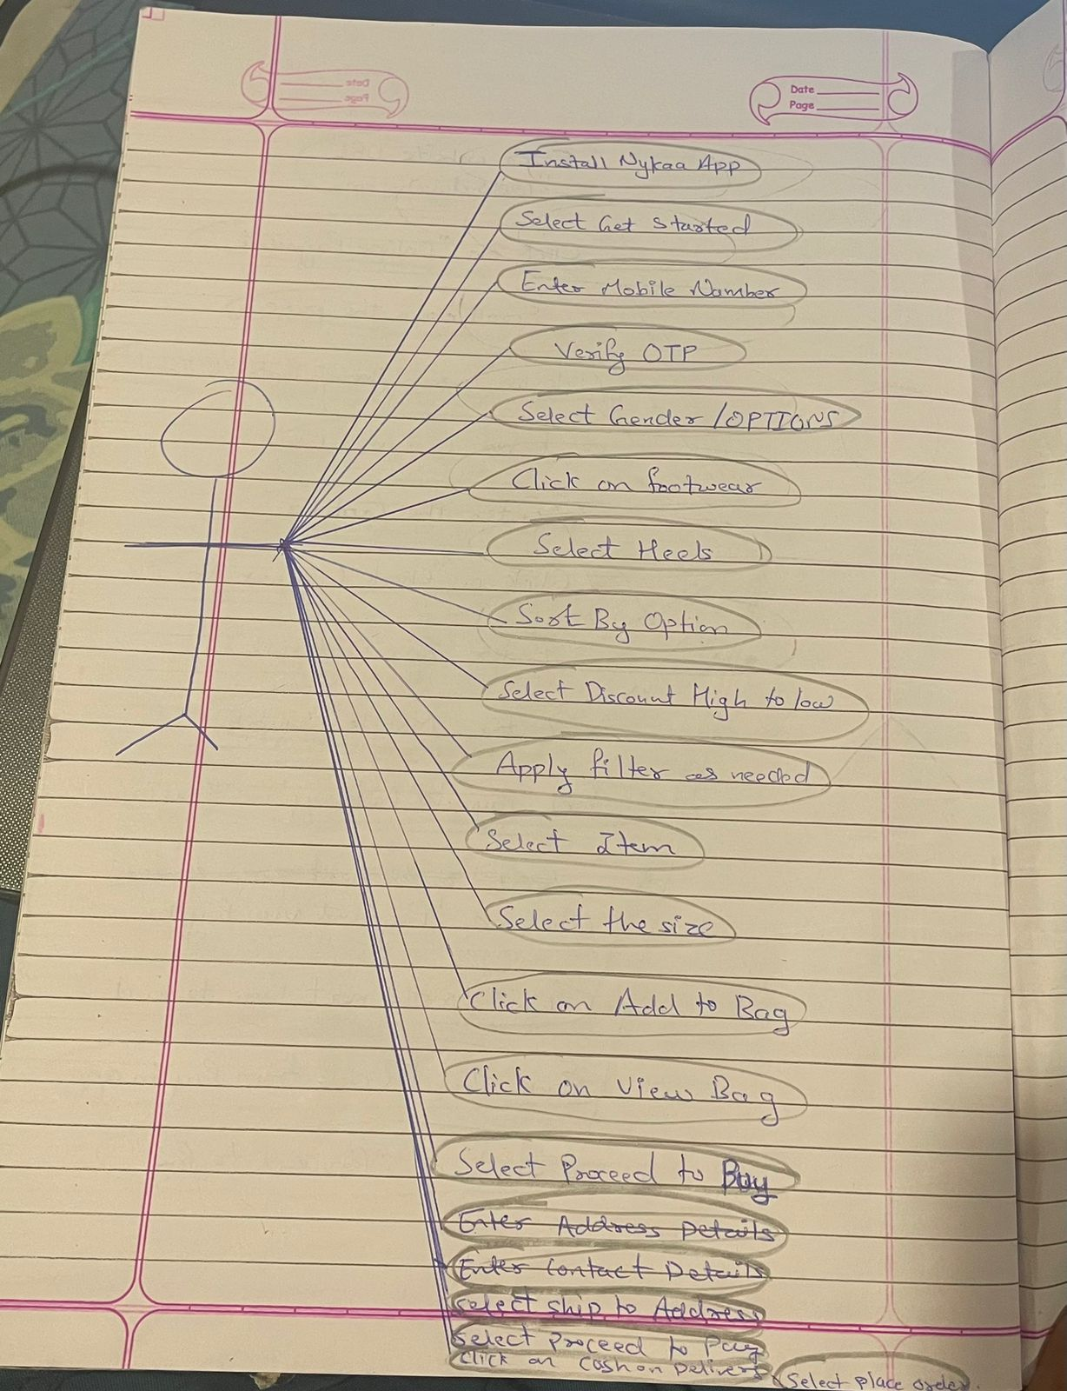

* Draw usecase on Online shopping product using payment gateway.

A)

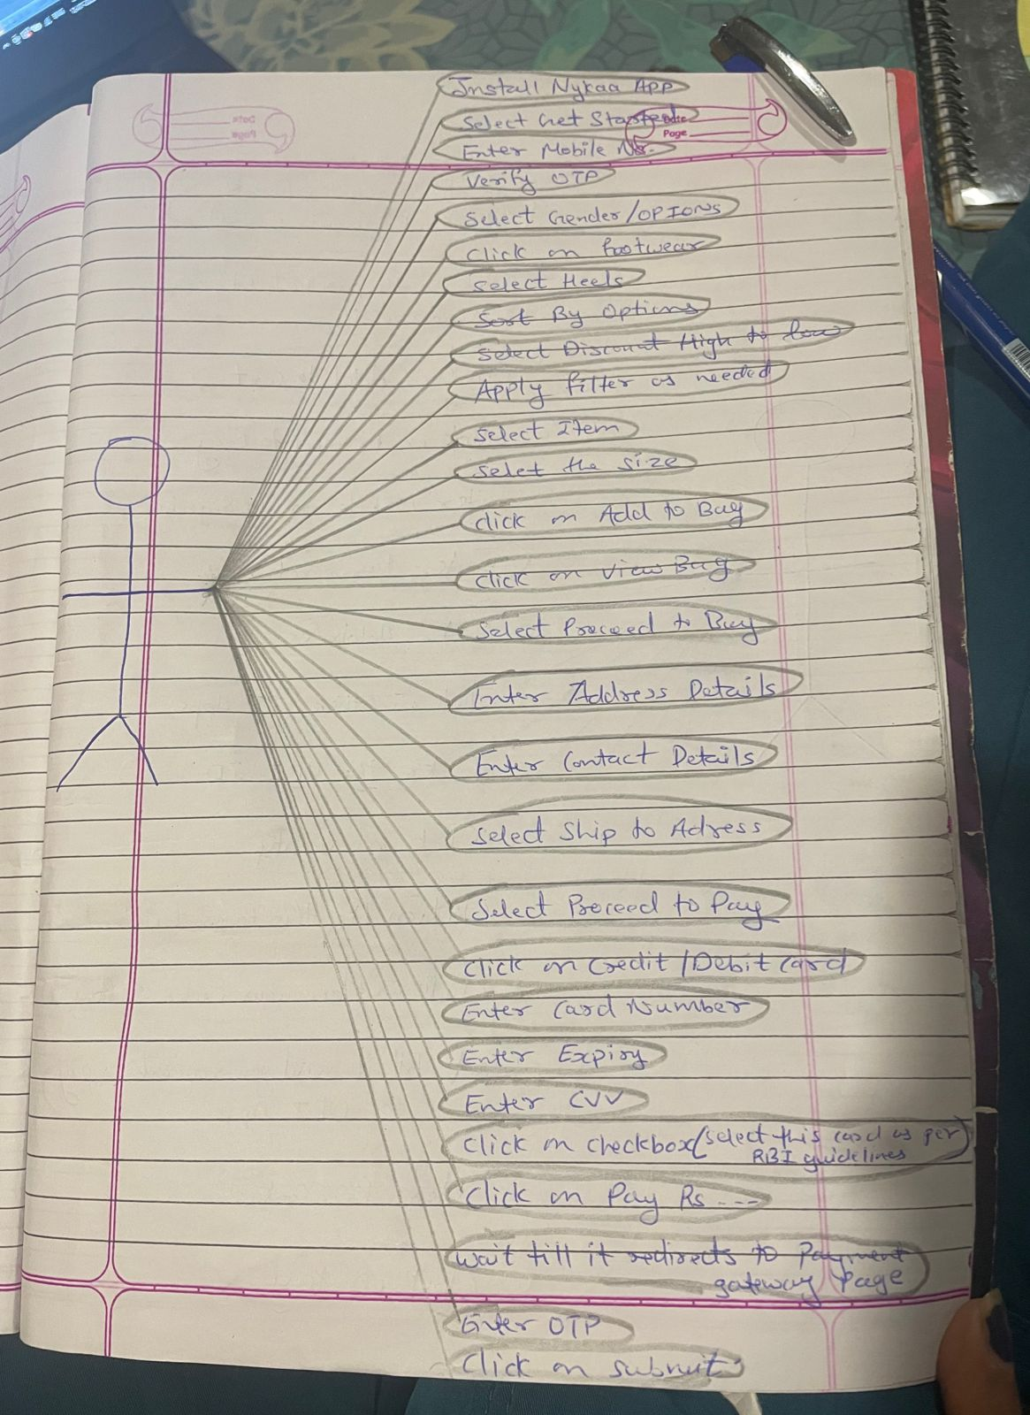

**Module–2(Manual Testing)**

• What is Exploratory Testing?

• What is traceability matrix?

• What is Boundary value testing?

• What is Equivalence partitioning testing?

• What is Integration testing?

• What determines the level of risk?

• What is Alpha testing?

• What is beta testing?

• What is component testing?

• What is functional system testing?

• What is Non-Functional Testing?

• What is GUI Testing?

• What is Adhoc testing?

• What is load testing?

• What is stress Testing?

• What is white box testing and list the types of white box testing?

• What is black box testing? What are the different black box testing techniques?

• Mention what are the categories of defects?

• Mention what bigbang testing is?

• What is the purpose of exit criteria?

• When should "Regression Testing" be performed?

• What is 7 key principles? Explain in detail?

• Difference between QA v/s QC v/s Tester

• Difference between Smoke and Sanity?

• Difference between verification and Validation

• Explain types of Performance testing.

• What is Error, Defect, Bug and failure?

• Difference between Priority and Severity

• What is Bug Life Cycle?

• Explain the difference between Functional testing and NonFunctional testing

• To create HLR & TestCase of 1)(Instagram , Facebook) only first page

2) Facebook Login Page : https://www.facebook.com/

• What is the difference between the STLC (Software Testing Life Cycle) and SDLC (Software Development Life Cycle)?

• What is the difference between test scenarios, test cases, and test script?

• Explain what Test Plan is? What is the information that should be covered.

• What is priority?

• What is severity?

• Bug categories are…

• Advantage of Bugzila .

• Difference between priority and severity

• What are the different Methodologies in Agile Development Model?

• Explain the difference between Authorization and Authentication in Web testing.What are the common problems faced in Web testing?

To create HLR & TestCase of WebBased (WhatsApp web , Instagram) 1. WhatsApp Web : https://web.whatsapp.com/

• To create HLR and TestCase on this Link. https://artoftesting.com/

• Write a scenario of only Whatsapp chat messages

• Write a Scenario of Pen

• Write a Scenario of Pen Stand

• Write a Scenario of Door

• Write a Scenario of ATM

• When to used Usablity Testing?

• What is the procedure for GUI Testing?

• Write a scenario of Microwave Owen

• Write a scenario of Coffee vending Machine

• Write a scenario of chair

• To Create Scenario (Positive & Negative)

2. Online shopping to buy product (flipkart)

• Write a Scenario of Wrist Watch

• Write a Scenario of Lift(Elevator)

• Write a Scenario of whatsapp Group (generate group)

• Write a Scenario of Whatsapp payment 

**Module 3 (Testing on Live Application)**

• What is RDBMS

• What is SQL

• Write SQL Commands

• What is join?

• Write type of joins.

• How Many constraint and describes it self

• Difference between RDBMS vs DBMS

• What is API Testing

• Types of API Testing

• What is Responsive Testing?

• Which types of tools are available for Responsive Testing

• What is the full form of .ipa, .apk

• How to create step for to open the developer option mode ON?

• To check

**Module-4 Automation Core Testing (Load Runner Up and Selenium IDE)**

• Which components have you used in Load Runner? 

• How can you set the number of Vusers in Load Runner? 

• What is Correlation? 

• What is the process for developing a Vuser Script? 

• How Load Runner interacts with the application? 

• How many VUsers are required for load testing? 

• What is the relationship between Response Time and Throughput? 

• To test the Performance testing on “Tops Technologies website” :- https://www.saucedemo.com/ 

1. to Record all top level menu

2. to Record minimum 10 Vuser on this website

3. save all (Script,Design,Graph)

• create a normal script of above website with correlate using hp default website. 

Selenium IDE)

• What is Automation Testing? 

• Which Are The Browsers Supported By Selenium Ide? 

• What are the benefits of Automation Testing? 

• What are the advantages of Selenium? 

• Why testers should opt for Selenium and not QTP? 

• To validate the tops technologies website Contact us page and enter your friend detail at last “Login and sidemenu” https://www.saucedemo.com/ 

**Advanced Selenium**

**Assignments Module – 5 (Selenium IDE)**

• What is Automation Testing? 

• Which Are The Browsers Supported By Selenium Ide? 

• What are the benefits of Automation Testing? 

• What are the advantages of Selenium? 

• Why testers should opt for Selenium and not QTP? 

• To validate the Swaglab website Login and logout process page https://www.saucedemo.com 

**Assignments Module – 6 (Core Java)**

• W.A.J.P to Take three numbers from the user and print the greatest number.

• W.A.J.P in Java to display the first 10 natural numbers using while loop.

• W.A.J.P to find factorial for Given Number.

• W.A.J.P to check given number is Prime or not?

• W.A.J.P to check given number is Armstrong or not?

• W.A.J.P for create Fibonacci Series.

• W.A.J.P to Print pattern Given Below.

1)

1

12

123

1234

12345

2)

1

12

123

1234

12345

3)

1

01

101

01010

101010

4)

1

2 2

3 3 3

4 4 4 4

5)

*

* * *

* * * * *

* * *

*

• WAP to compute the sum of the first 100 prime numbers.

• WAP to sum values of an array.

• WAP to calculate the average value of array elements.

• WAP to find the index of an array element.

• WAP to find the maximum and minimum value of an array.

• WAP to Compare Two String.

• WAP to concatenate a given string to the end of another string.

• WAP to demonstrate try catch block.

• WAP to demonstrate multiple catch blocks

• WAP to create one thread by implementing Runnable interface in Class.

• WAP to create one thread by extending Thread class in another

Class.

• WAP to iterate through all elements in an array list.

• WAP to update specific array element by given element.

• WAP to remove the third element from a array list.

• WAP to Copy one array into another

• WAP to reverse an array of integer values.

• WAP to find the second largest element in an array.

• W.A.J.P. Create an abstract class 'Parent' with a method 'message'. It has two subclasses each having a method with the same name

'message' that prints "This is first subclass" and "This is second subclass" respectively.

Call the methods 'message' by creating an object for each subclass.

• W.A.J.P. which will ask the user to enter his/her marks (out of 100). Define a method that will display grades according to the marks entered as below:

Marks Grade

91-100 AA

81-90 AB

71-80 BB

61-70 BC

51-60 CD

41-50 DD

<=40 Fail

• W.A.J.P. to create a custom exception if Customer withdraw amount which is greater than account balance then program will show custom exception otherwise amount will deduct from account balance.

Account balance is:2000 Enter withdraw amount:2500

Sorry, insufficient balance, you need more 500 Rs. To perform this transaction.

**Module – 7 (Selenium Webdriver)**

**Demo Websites To Practice selenium Webdriver**

**Website List**

• 1 List of Websites to Practice Selenium

o 1.1 1. https://phptravels.com/demo/

o 1.2 2. http://thedemosite.co.uk/

o 1.3 3. http://newtours.demoaut.com/

o 1.4 4. http://the-internet.herokuapp.com/

o 1.5 5. http://automationpractice.com/index.php

o 1.6 6. http://book.theautomatedtester.co.uk/

o 1.7 7. https://s1.demo.opensourcecms.com/wordpress/

• W.A.J.Script for Locating links by linkText() and partialLinkText()

• W.A.J.Script for Selecting multiple items in a drop dropdown

• W.A.J. script to use different methods to manage the windows-alerts and pop ups.

• W.A.J.script to register your self in Gmail.

• W.A.J. Script To perform the radio button to select one by one in loop http://demo.guru99.com/test/radio.html

• W.A.J. script To write the script for image of logo facebook using xpath.

• W.A.J.Script To write a script for drop down. http://demo.guru99.com/test/newtours/register.php

• W.A.J.Script To use Mouse and Keyboard event using Action class 1.Mouse Hover Event

2. Keyboard event

• W.A.J. Script How to handled Alert in selenium "http://demo.guru99.com/test/delete_customer.php "

• W.A.J. Script To find the total hyperlink from this web page http://demo.guru99.com/test/web-table-element.php

• W.a.junit program to handled Assert class with all method to check its pass or fail

• W.a. junit program to perform test with webdriver to login process of

facebook

• W.a. junit program to check gmail login using with @before,@after,@Test

• W.a. junit program to use parameterized demo with multiple

parameter of Facebook login in junit.

• W.a. TestNG program to perform test with webdriver to login process of facebook

• W.a. TestNG program to check gmail login using with @beforetest,@aftertest,@Test

• W.a. TestNG program to use parameterized demo with multiple parameter of Facebook login with TestNG.

• W.a. TestNG program to create group with testing.xml file

• w.a. TestNG program to create dataprovider.

**Module – 8 (Automation Testing Framework)**

• W.a.framework program for data driven framework

-to get value from the excel and check into your website (http://automationpractice.com/index.php?controller=authentication&b ack=my-account) Direct check with login which emaild through login successful or not)

• W.a.framework program for keyword driven framework

-given below keyword which you get from the Excel and check into you website (http://automationpractice.com/index.php)

• W.a.framework program for hybrid driven framework

-given below keyword and Data both which you get from the Excel and check into you website (http://automationpractice.com/index.php)

• W.a.maven program to create simple webdriver Program

• **W.a.maven program to create Junit with webdriver Program**

• W.a.maven program to create TestNG with Webdriver Program.

Module – 9 (APPIUM Testing)

1) Write an Appium Program to connect with emulator and open APIdemo.app application on your emulator

2) Write an Appium Program to connect with Realdevice and open APIdemo.app application on your realdevice.

3) Write an Appium Program to connect with emulator wit ecommerce based application using Generalstore.app to perform locators like name, dropdown etc.

4) Write an Appium Program to connect with emulator wit ecommerce based application using Generalstore.app to perform swipe demo to swipe the menu.

5) Write an Appium Program to connect with realdevice using APIDemo.app to perform longpress to open to side menu.

6) Write an Appium Program to connect with realdevice using APIDemo.app to perform scrolling the all option.

7) Write an Appium Program to connect with realdevice using APIDemo.app to open the calculator and calculate all the operation like (addition, substraction, multiplication, division).

Module – 10 (API Testing)

Api testing link : https://restapilive.onrender.com/

1) to test in above API which is passed in parameter as a column in user module to check the registration performed or not and get the result is coming or not (Method=POST)

2) to test in above API which is performed login wit using parameter in user module and check generate token or not (Method=POST)

3) to test in above API which is performed login wit using parameter in admin module and check generate token or not (Method=POST)

4) to test in above API which is performed login wit using parameter in admin module and check generate token header : [admin-auth-token : got from admin login] and add category with the help of token (Method= POST)

5) to test in above API which is performed login wit using parameter in admin module and check generate token [admin-auth-token : got from admin login] to display all the category (Method=GET)

6) to test in above API which is performed login wit using parameter in admin module and check generate token[admin-auth-token : got from admin login] to delete the category (Method=GET)